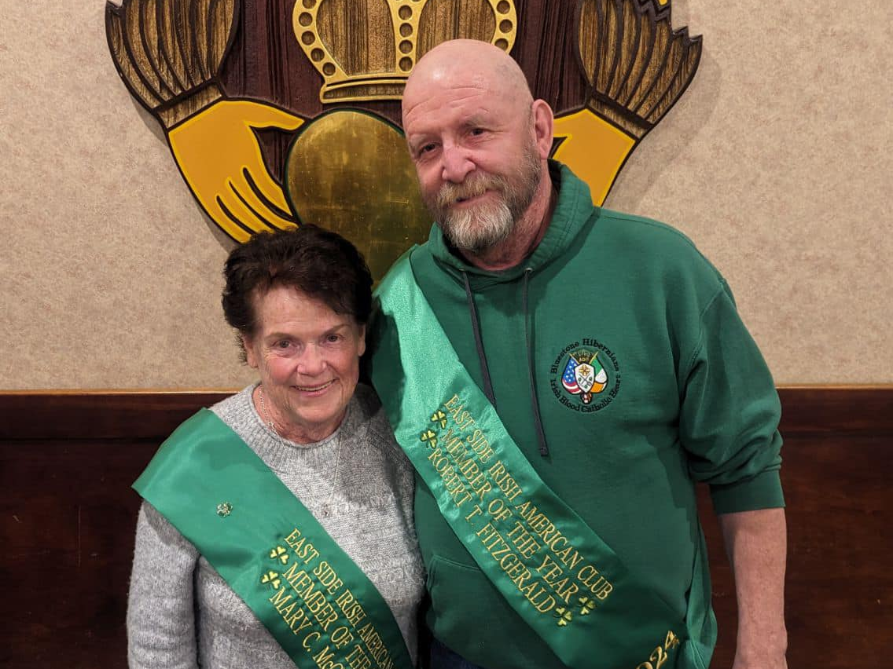
Member of the Year
Mary C. McCluskey
The Executive Board is happy to have chosen Mary C. McCluskey for our Member of the Year 2024. Mary was born December 16 to her parents Nora & Thomas Hastings from County Mayo, Ireland. She has loved and studied Irish music and customs since early childhood, dancing with the Gaelic League Society Dancers along with her sister Norine and brothers Thomas and Frank.
Mary attended St. Philomena Grade School and Ursuline Sacred Heart Academy in East Cleveland. When she was a freshman in high school Mary joined the West Side Irish American Club’s Ladies Drill Team. By 1962 she became the leader of the Drill Team and continued for over 50 years, known as Sergeant Major” before handing over the reins to her daughter Katie. She was very instrumental in assisting her sister Norine and Heather O’Brien with the Irish American Club East Side’s Ladies Drill Team.
In 1962 Mary met her husband Joe at the West Side Irish American Club and they were married February 3, 1962. Mary & Joe had seven children, Mary, Christine, Kevin, Tom, Tricia, Maureen and Katie. She is so proud of her grandchildren, Andrew and Patrick Philion, Sean, Meghan and Cara O’Donnell. She has passed along her love of her Irish heritage to her family and enjoys traveling to the Irish Dance Feis’s to watch her granddaughters Meghan and Cara compete.
For the past few years Mary has been handling the Club’s hall rentals and our Tuesday Ladies Cleaning Crew. You will never see her at a Club function where she isn’t walking around doing something. We thank her for all that she has done and continues to do for our Club.

Member of the Year
Robert (Fitz) T. Fitzgerald
Robert Thomas Fitzgerald (Bob) is better known as “Fitz” to all who know him. He is the eldest of six children born to Robert and Corrine Fitzgerald (Quinlan). His siblings include Jeanne, Mary Alice, Kathleen, Sharon, and Sean. He attended St. Paul’s School in Euclid and then attended St. Joseph High School. Bob earned the rank of Eagle Scout, which may surprise some, but not those who know him well.
After high school Bob attended The Ohio State University. His attire definitely lets people know he is proud Buckeye alum. Take for example his signature OSU polo. In Fitz's opinion, it is very versatile. He believes it can be worn casually with a pair of shorts or add a velour smoking jacket and it is suitable to be worn to dinner at Ashford Castle in Ireland. This of course was much to his traveling companion’s dismay.
He married Shelly Gardner on September 14th, 1996. And on March 10, 1999, Daddy's little girl, Gabrielle, was born. The family resides in Euclid.
If Bob is not helping out here at the Irish American Club, or at a friend or family's home, he is most likely at his personal slice of heaven, their cottage in Andover. For many years, volleyball was Bob's passion. He played in several men’s leagues for both the city of Euclid and Turners. Additionally, coached both CYO and JO and helped found the Utopia Beach Club Junior Olympics Club.
Bob retired in 2017 from the State of Ohio where he was a tax auditor for over 30 years. After his retirement he spent most days caring for his father with the help of his siblings. These days, meeting up with friends and family for morning coffee or a few beers at night is some of his favorite time spent. He even claims he plays a weekly round of golf.
Fitz is a long-time member of the Irish American Club Eastside. He has been co-chairing the 317 Raffle since its inception, he has volunteered as a bartender, and shows up on Tuesday for club clean up and chaired the OSU vs. Michigan party. “Banger Boards”, which have been used at many events to help raise money for the club over the years, was his brilliant contribution.
He is also a member of the Ancient Order of Hibernians, Bluestone Division where he serves as an officer and also their delegate to the United Irish Society. Whether it is something that is needed to be done here at the club, or if there is a friend or family that needs a helping hand, Bob can always be counted on to be there for you.
Ask those that know and love him; they will tell you he is the best big brother, cousin, father, friend, husband and sport anyone could ask for. The fact that Fitz has never met a stranger tells you what a generous and welcoming soul he is.
The Irish American Club East Side is proud to recognize Bob Fitzgerald as its 2024 Member of the Year.

