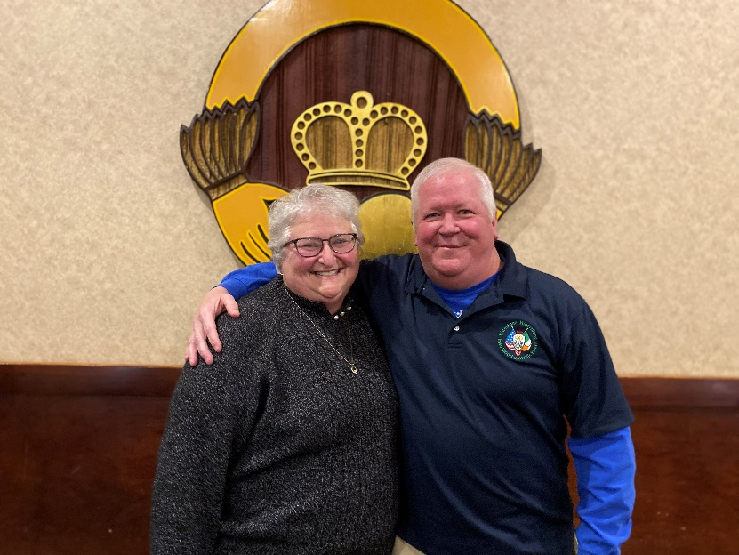
Member of the Year
Michael Joseph Byrne
On July 3, 1961 with early fireworks Michael Joseph Byrne was born to Jackie and Pat Byrne. Michael is the fourth of six children. He attended St. Margaret Mary grade school, Cathedral Latin High School, and the University of Dayton and remains a dedicated “Flyers Fan”. He enjoyed bowling, racquetball and excels at beer consumption. He enjoys placing bets and traveling for horse racing and NASCAR.
To know Michael is to know that he is very family oriented. He is the “fun uncle” to his many nieces and nephews. He is the chief cook at his family’s winter party and spends the day providing commentary to everyone who approaches the grill. He along with his siblings cared for their mother who passed away from cancer and his father who had MS for many years. He cared for them both until their passing and if you are a friend of his you feel like you knew them both with the many stories he shares. Michael worked multiple jobs before becoming a property manager of several rental properties with his business partner.
If you know Michael, you know that he sometimes can be brutally honest and never says anything behind one’s back that he won’t say to one’s face. He was a Dictator for Life of his golf league for more than 20 years and is now Dictator Emeritus (both his own self-named titles). He has an active imagination living in a world called “Mikeyland” where he makes the rules and can change them at will. He sings out of tune and changes the words to any country song on the radio to include “Martha” if the song mentions a woman. Martha by the way lovingly known as “Miss Martha” to many, has been married to Michael for 32 years and every St. Patrick’s Day they celebrate their anniversary.
Michael has served on the Executive Board as Member at Large. He is the pancake maker for the children’s Breakfast with Santa. Michael began the OSU vs. Michigan tailgate party with donations of peanut butter and jelly sandwiches for those in need. He is the ace ticket seller for the Bluestone Division Hibernian reverse raffle and is co-chair of the 317 raffle. He has worked on several maintenance projects here at the Club and most recently was instrumental in the renovation of the Phil Walsh Cabaret Room. Michael, we thank you for all of the things you have done for the Club and we are proud to honor you as our Member of the Year.

Member of the Year
Mary Jo Gurry
The Executive Board’s choice for the 2022 Member of the Year is Mary Jo Gurry! Mary Jo was born to Larry and Anise Loren. She has three brothers; Rick, Larry and Tom, and two sisters; Patty and Nancy. The family lived on Clarkstone Road in East Cleveland and belonged to Christ the King with all the children attending the parish school. Mary Jo went on to attend Notre Dame Academy (“class head to toe” as the NDA grads say), then Cuyahoga Community College where she earned her degree as a dental hygienist.
Mary Jo loves her Irish heritage. She joined the Irish American Club East Side when it was formed in 1978, proudly being Charter Member #99 and an editor of The Schanachie. Mary Jo also met the love of her life at the Club. As the story goes, Mary Jo was bartending at a Club event held at the old Elks Lodge when a crazy rugby player named Jon Gurry came in and put his feet on the bar. Mary Jo knocked those feet right off the bar and they’ve been together ever since. Theirs was one of the first weddings held at the Club in the new location in 1983.
The Gurry’s have three daughters: Maggie, Brigid and Alana. The girls attended St. Robert Bellarmine and Mary Jo was very involved in the parish and school. She was the cafeteria manager for many years and very active in the PTU and other parish events. When the girls entered high school, Mary Jo went to work at Euclid Hospital as secretary in the Radiology Department, retiring in 2016.
Retirement gave Mary Jo more time to be involved in the Club, volunteering with the after-funeral luncheons and as the current ticket co-chair. Mary Jo runs a “tight ship”, making sure that everyone gets the seat or table they want and handles last minute issues to make our events run smoothly. You will find Mary Jo sitting at the door greeting everyone with her lovely smile! When not involved with Club activities, Mary Jo is an avid gardener and cruiser. If you want to see that signature Mary Jo smile, ask her about her next cruise or better yet, her favorite birthday gift, grandson Henry.
Mary Jo is dedicated to her family, friends and our Club. She and Jon love getting together with the Old Timers to reminisce about all the happy times they have had at the Club over the past 44 years.
We are very grateful to Mary Jo for her service to our Club, now and in the past. Enjoy the weeks ahead, for now it’s time for us to honor you!

